**Lab Work #01**

CSC103-Programming Fundamentals



Submitted by:

**ARFA RIAZ**

**FA23-BCS-035**

**Section A**

Submitted to:

**Mr. Abdul Karim Shahid**

Submitted on: **September 30, 2023**

**Department of Computer Science**

**COMSATS University Islamabad**

**Lahore Campus**



**Exercise 1:** Print following shape using simple printf statements (You may print these shapes vertically in one program)

(1) (2) (3) (4) (5) (6)

* ********** * * ***** *****  
 *** * * ** ** **** ****  
 ***** * * *** *** *** ***  
 *** * * **** **** ** **  
 * ********** ***** ***** * *

#include<stdio.h>

int main()

*//function main begins program execution*

{

*//Exercise 1: Printing shapes using simple printf statements*

printf(" * \n");

printf(" ***** \n");

printf(" ******* \n");

printf(" ********* \n");

printf(" *********** \n");

printf(" ********* \n");

printf(" ******* \n");

printf(" ***** \n");

printf(" * \n");

printf("\n ************ \n");

printf(" * * \n");

printf(" * * \n");

printf(" * * \n");

printf(" * * \n");

printf(" * * \n");

printf(" * * \n");

printf(" * * \n");

printf(" ************ \n");

printf("\n* \n");

printf(" ** \n");

printf(" *** \n");

printf(" **** \n");

printf(" ***** \n");

printf(" ****** \n");

printf(" ******* \n");

printf(" ******** \n");

printf(" ********* \n");

printf(" ********** \n");

printf(" *********** \n");

printf(" ************ \n");

printf("\n * \n");

printf(" ** \n");

printf(" *** \n");

printf(" **** \n");

printf(" ***** \n");

printf(" ****** \n");

printf(" ******* \n");

printf(" ******** \n");

printf(" ********* \n");

printf(" ********** \n");

printf(" *********** \n");

printf(" ************ \n");

printf("\n************ \n");

printf(" *********** \n");

printf(" ********** \n");

printf(" ********* \n");

printf(" ******** \n");

printf(" ******* \n");

printf(" ****** \n");

printf(" ***** \n");

printf(" **** \n");

printf(" *** \n");

printf(" ** \n");

printf(" * \n");

printf("\n ************ \n");

printf(" *********** \n");

printf(" ********** \n");

printf(" ********* \n");

printf(" ******** \n");

printf(" ******* \n");

printf(" ****** \n");

printf(" ***** \n");

printf(" **** \n");

printf(" *** \n");

printf(" ** \n");

printf(" * \n");

**return** 0; *//indicating that program ended successfully*

} *//end function main*

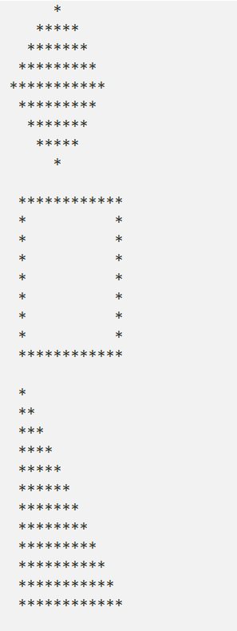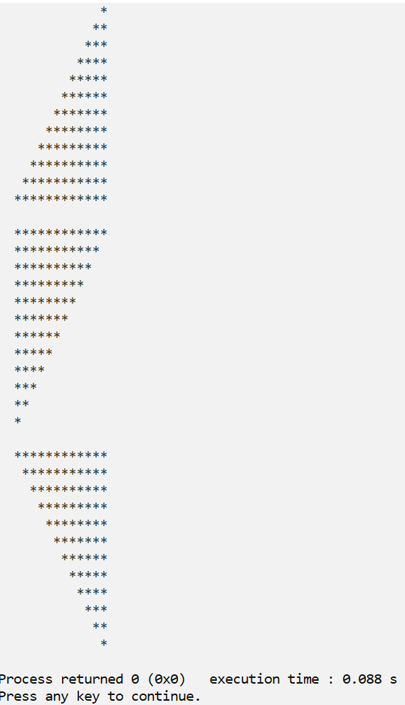

**Exercise 2:** Write a program that prints the numbers 1 to 4 on the same line. Write the program using the following methods.

1. Using one printf statement with no conversion specifiers.
2. Using one printf statement with four conversion specifiers.
3. Using four printf statements

#include<stdio.h>

int main()

*//function main begins program execution*

{

*// Writing a program that writes the number 1 to 4 in the same line.*

*// a) Using one printf statement with no conversion specifiers.*

printf(" 1, 2, 3, 4\n");

*// b) Using one printf statement with four conversion specifiers.*

*// 1.) using just one type of conversion specifier*

printf(" %d, %d, %d, %d\n", 1, 2, 3, 4);

*// 2.) using four different types of conversion specifiers*

printf(" %d, %0.1f, %c, %s\n", 1, 2.0, '3', "4");

*// c) Using four printf statements*

printf(" 1,");

printf(" 2,");

printf(" 3,");

printf(" 4\n");

**return** 0; *//indicating that program ended successfully*

} *//end function main*

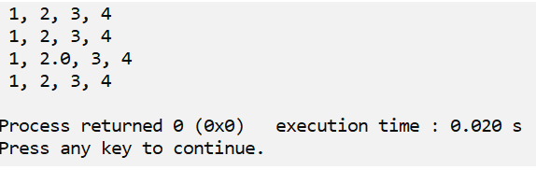

**Exercise 3:** Write a C-Program to perform the simple arithmetic operations (addition, subtraction, multiplication, division, remainder).

#include<stdio.h>

int main()

*//function main begins program execution*

{

*// Writing a C Program to perform simple arithmetic operations*

*// No. 1*

printf("ARITHMETIC OPERATIONS USING INTEGER VALUES\n");

printf(" %d + %d = %d\n", 2, 2, 2**+**2);

printf(" the sum of %d and %d is %d\n", 6, 2, 6**+**2);

printf(" %d - %d = %d\n", 7, 3, 7**-**3);

printf(" difference of %d and %d is %d\n", 105, 67, 105**-**67);

printf(" %d * %d = %d\n", 70, 100, 70 **\*** 100);

printf(" the product of %d and %d is %d\n", 80, 23, 80**\***23);

printf(" %d / %d = %d\n", 80, 2, 80**/**2);

printf(" the division of %d and %d is %d\n", 240, 8, 240**/**8);

printf(" %d % %d = %d\n", 9, 7, 9**%**7);

printf(" the mod of %d and %d is %d\n", 234, 8, 234**%**8);

*//No. 2*

printf("ARITHMETIC OPERATIONS USING FLOATING VALUES\n");

printf(" %0.1f + %0.1f = %0.1f\n", 2.0, 2.0, 2.0 **+** 2.0);

printf(" the sum of %0.1f and %0.1f is %0.1f\n", 6.3, 2.5, 6.3**+**2.5);

printf(" %0.1f - %0.1f = %0.1f\n", 4.8, 2.9, 4.8**-**2.9);

printf(" difference of %0.1f and %0.1f is %0.1f\n", 105.9, 67.6, 105.9**-**67.6);

printf(" %0.1f * %0.1f = %0.1f\n", 6.0, 7.0, 6.0**\***7.0);

printf(" the product of %0.1f and %0.1f is %0.1f\n", 6.7, 99.9, 6.7**\***99.9);

printf(" %0.1f / %0.1f = %0.1f\n", 9.0, 3.0, 9.0**/**3.0);

printf(" the division of %0.1f and %0.1f is %0.1f\n", 234.0, 8.0, 234.0**/**8.0);

**return** 0; *//indicating that program ended successfully*

} *//end function main*

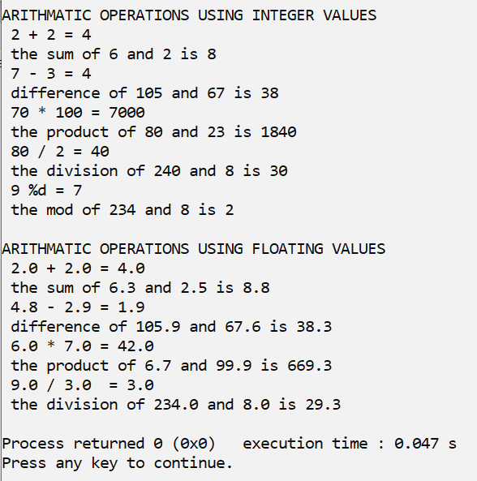

**Exercise 4:** Write a C-Program to swap two integer numbers without and with using a third variable.

#include<stdio.h>

int main()

*//function main begins program execution*

{

*//Writing a C Program to swap two integer numbers.*

printf("EXERCISE 4 (part 1) WITH A THIRD VARIABLE\n");

int x,y,temp ;

printf("ENTER FIRST NUMBER\n");

scanf("%d",**&**x);

printf("ENTER SECOND NUMBER\n");

scanf("%d",**&**y);

printf("BEFORE SWAPPING\n");

printf("x=%d, y=%d\n", x,y);

temp**=**x;

x**=**y;

y**=**temp;

printf("AFTER SWAPPING\n");

printf("x=%d, y=%d\n", x,y);

**return** 0; *//indicating that program ended successfully*

} *//end function main*

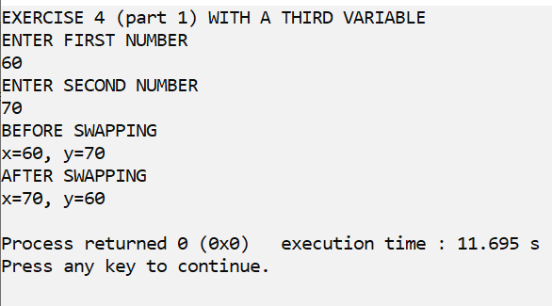

#include<stdio.h>

int main()

*//function main begins program execution*

{

*//Writing a C Program to swap two integer numbers without a third variable.*

printf("EXERCISE 4 (part 2) WITHOUT A THIRD VARIABLE\n");

int x,y;

printf("ENTER FIRST NUMBER\n");

scanf("%d",**&**x);

printf("ENTER SECOND NUMBER\n");

scanf("%d",**&**y);

printf("BEFORE SWAPPING\n");

printf("x=%d, y=%d\n", x,y);

x**=** x**+**y;

y**=** x**-**y;

x**=** x**-**y;

printf("AFTER SWAPPING\n");

printf("x=%d, y=%d\n", x,y);

**return** 0; *//indicating that program ended successfully*

} *//end function main*

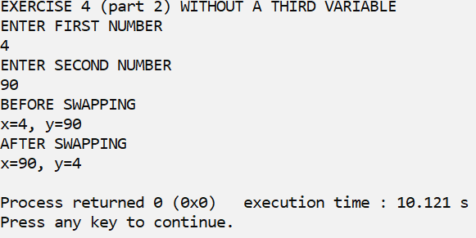

**Exercise 5:** Write a C-Program to calculate the area and Perimeter of the triangle.

[Area of triangle= ½ x base x vertical height]

[Perimeter of triangle = a + b + c]

#include<stdio.h>

int main()

*//function main begins program execution*

{

*//A C-Program to calculate Area of the triangle.*

float base,vh; *// vh= vertical height*

printf("ENTER BASE VALUE: \n");

scanf("%f",**&**base);

printf("ENTER VERTICAL HEIGHT VALUE: \n");

scanf("%f",**&**vh);

*//Area of triangle= ½ x base x vertical height*

printf("AREA OF TRIANGLE= %0.2f\n", 0.5 **\*** base **\*** vh);

**return** 0; *//indicating that program ended successfully*

} *//end function main*

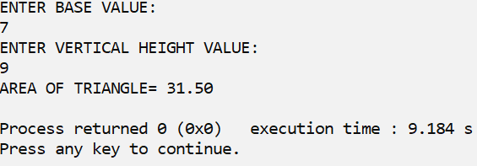

#include<stdio.h>

int main()

*//function main begins program execution*

{

*//A C-Program to calculate the Perimeter of the triangle.*

float side1,side2,side3 ;

*// User enters the values of the length of sides of triangle*

printf("ENTER THE LENGTH OF 1ST SIDE OF TRIANGLE: \n");

scanf("%f",**&**side1);

printf("ENTER THE LENGTH OF 2ND SIDE OF TRIANGLE: \n");

scanf("%f",**&**side2);

printf("ENTER THE LENGTH OF 3RD SIDE OF TRIANGL: \n");

scanf("%f",**&**side3);

*//[Perimeter of triangle = side1 + side2 + side3]*

printf("PERIMETER OF TRIANGLE= %0.2f\n", side1 **+** side2 **+** side3);

**return** 0; *//indicating that program ended successfully*

} *//end function main*

